### IoT Based Safety Gadget for Child Safety Monitoring and Notification

TECHNOLOGY ARCHITECTURE:

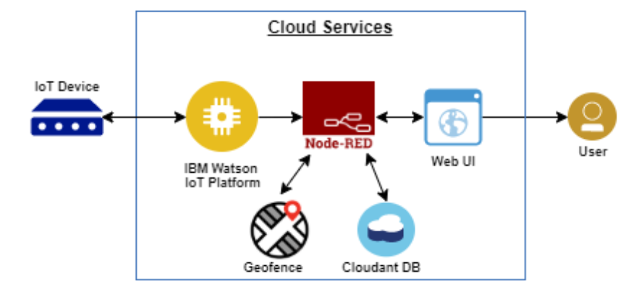

**TEAM ID: PNT2022TMID37952**

**TEAM BATCH NO: B7-1A3E**

**TEAM MENTOR: R. PADMAVATHY**

**TEAM LEADER: S. MADHUVANTHHI**

**TEAM MEMBERS :P. GLANY ROSE**

**V. POOJA**

**R. SANGEETHA**

**TEAM SIZE: 4**